UC 1: Register

|  |  |
| --- | --- |
| **Precondition: System does not have a registered account in the Arlington Auto Car Rental System for the System User and on the Main Application screen.** | |
| **Actor: System User (Admin, User, Rental Manager)** | **System: Arlington Auto Car Rental System** |
|  | 0.System displays the Main Application screen **(Figure 1.1).** |
| **1. TUCBW** the System User selects the Register function on Main Application screen. | 2.System displays the registration form on Registration screen **(Figure 1.2)**. |
| 3.System user fills the details and clicks on register button. | *  4. On successful registration:  System displays ‘Registration Successful’ messageand user is redirected back to Main Application screen **(Figure 1.3)**.  On Unsuccessful registration:  System displays ‘Username already exists’ message on Registration screen **(Figure 1.4)**. |
| **5.TUCEW** System user sees the ‘Registration Successful’ message and sees the return to the Main Application screen. |  |
| **Post condition: The system creates a new account for system user** | |

**Figure 1.1 Figure 1.2 Figure 1.3**

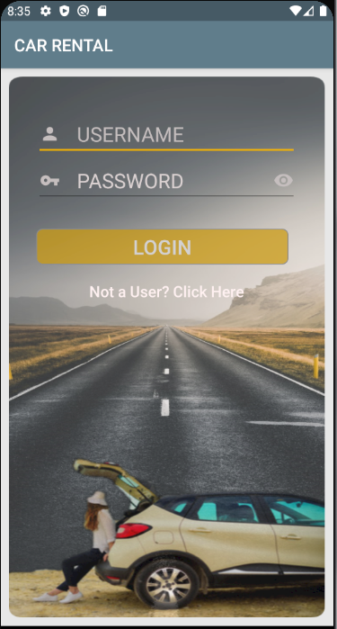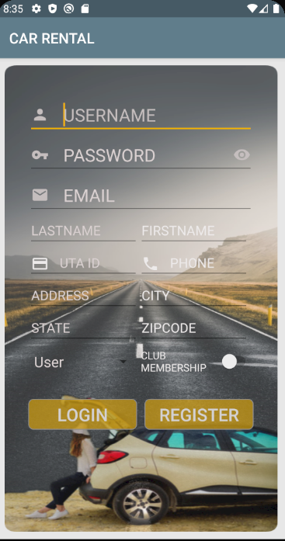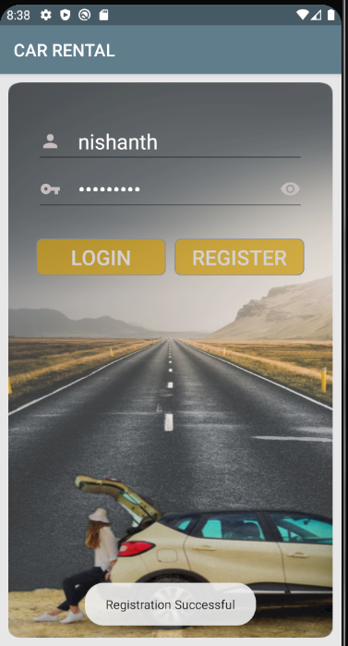

**Figure 1.4**

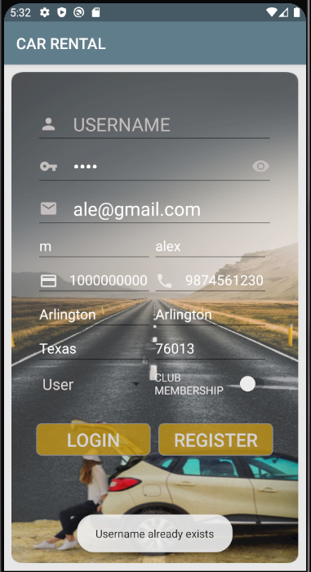

UC 2: Login

|  |  |
| --- | --- |
| **Precondition: The system has an account in the Arlington Auto Car Rental System for the System User and on the Main Application screen.** | |
| **Actor: System User (User, Admin, Rental Manager)** | **System: Arlington Auto Car Rental System** |
|  | 0. System displays the Main Application screen **(Figure 1.1).** |
| **1. TUCBW** the System User enters the username and password and selects the “Login” function on Main Application screen. | *  2. The system displays different screens in different scenarios indicating successful login   1. Admin will be shown Admin Home screen **(Figure 2.1).** 2. Rental Manager will be shown Rental Manager Home screen **(Figure 2.2).** 3. User will be shown User Home screen **(Figure 2.3).**   For unsuccessful login:   * Error messaged is shown for incorrect login credentials **(Figure 2.4)**. |
| **3. TUCEW** the System user obtains access into the system. System User sees their functions as an indication of successful login on their Home screen. |  |
| **Post condition: The system grants access to the System User who obtains access to the appropriate user functions.** | |

**Figure 1.1 Figure 2.1 Figure 2.2**

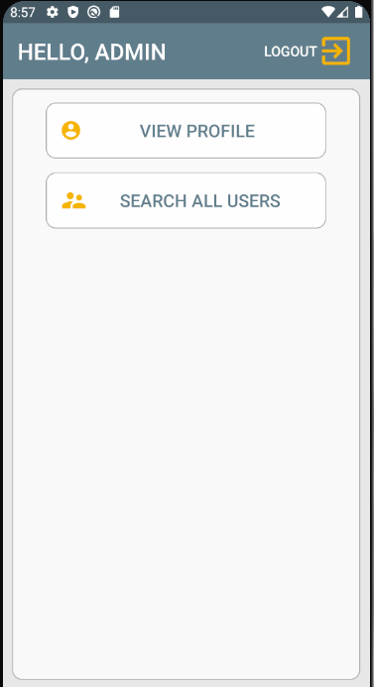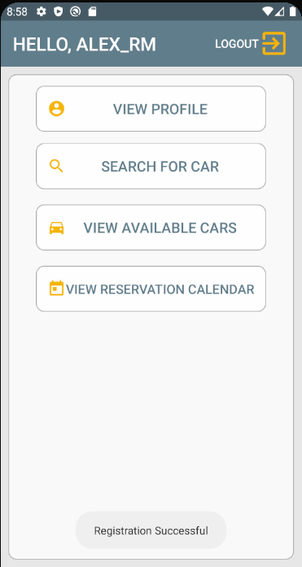

**Figure 2.3 Figure 2.4**

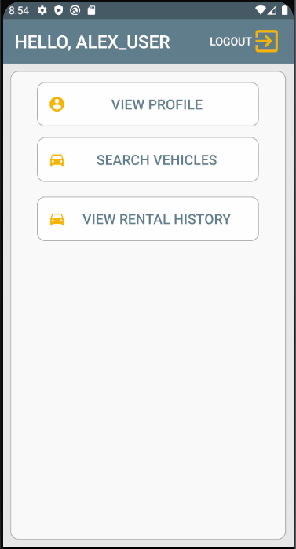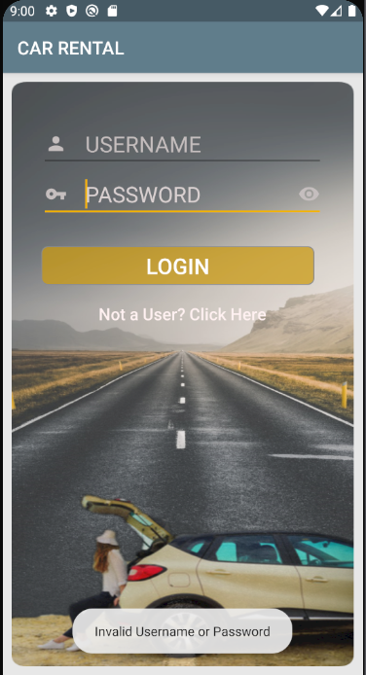

UC 3: Logout

|  |  |
| --- | --- |
| **Precondition: The system has an account for the System User in the Arlington Auto Car Rental System that is logged in and on the System User Home screen.** | |
| **Actor: System User (Admin, Rental Manager, User)** | **System: Arlington Auto Car Rental System** |
|  | 0. System displays the System User Home Screen  1. Admin **(Figure 2.1)**.  2. Rental Manager **(Figure 2.2)**.  3. User **(Figure 2.3)**. |
| **1. TUCBW** the System User selects the “Logout” function on System User Home Screen. | 2. The system logs out the user and redirects to the Main Application screen **(Figure 1.1)**. |
| **3. TUCEW** the System User loses access to the system and is returned to the Main Application screen. |  |
| **Post condition: The System prevents the System User from accessing the system.** | |

**Figure 2.1 Figure 2.2 Figure 2.3**



**Figure 1.1**



UC 4: View Profile

|  |  |
| --- | --- |
| **Precondition: The system has an account for the System User in the Arlington Auto Car Rental System that is logged in and on the System User Home screen.** | |
| **Actor: System User (User, Admin, Rental Manager)** | **System: Arlington Auto Car Rental System** |
|  | 0. System displays the System User Home screen  1. Admin **(Figure 2.1)**.  2. Rental Manager **(Figure 2.2)**.  3. User **(Figure 2.3)**. |
| **1. TUCBW** the System User selects the “View Profile” function on System User Home Screen. | *  2. The system displays the System User’s View Profile screen   1. Admin is shown Admin details **(Figure 4.1)**. 2. Rental Manager is shown Rental Manager details **(Figure 4.2)**. 3. User is shown User details **(Figure 4.3)**. |
| **3. TUCEW** the System User sees profile details on the System User’s View Profile screen. |  |
| **Post condition: The system displays the System User’s information.** | |

**Figure 2.1 Figure 2.2 Figure 2.3**



**Figure 4.1 Figure 4.2 Figure 4.3**

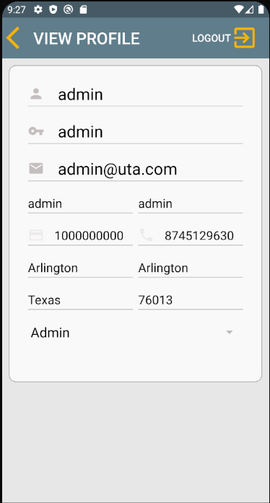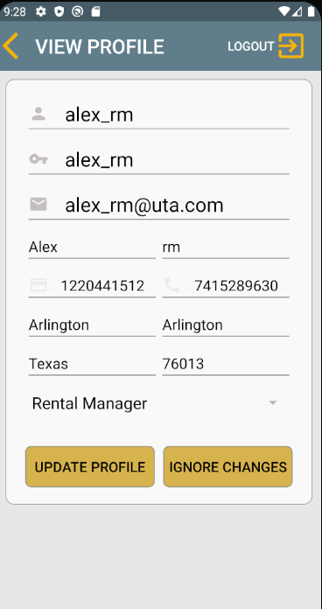 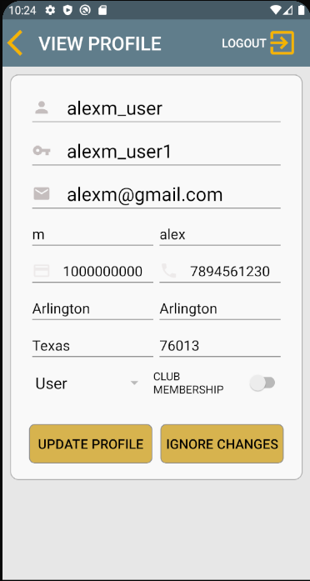

UC 5: Update Profile

|  |  |
| --- | --- |
| **Precondition: The system has an account for the System User in the Arlington Auto Car Rental System that is logged in and on View Profile screen.** | |
| **Actor: System User (User, Rental Manager)** | **System: Arlington Auto Car Rental System** |
|  | 0. System displays the View Profile screen**.**   1. Rental Manager is shown Rental Manager details **(Figure 4.2)**. 2. User is shown User details **(Figure 4.3)**. |
| **1. TUCBW** the System User updates one or more fields and selects the “Update Profile” function on System User View Profile screen | 2. The system displays a confirmation message to the System user on View Profile screen. **(Figure 5.1)** |
| 3. The System user can either click ‘YES’ or ‘NO’ with respect to updating the System User’s profile. | *  4. The system updates the System User’s details and displays the confirmation message on the View Profile screen.   1. Rental Manager is shown Rental Manager details **(Figure 5.2)**. 2. User is shown User details **(Figure 5.3)**. |
| **5. TUCEW** the System User sees ‘Account Details Updated’ message and returns to the View Profile screen. |  |
| **Post condition: The system displays the System User’s profile information** | |

**Figure 4.2 Figure 4.3 Figure 5.1**

 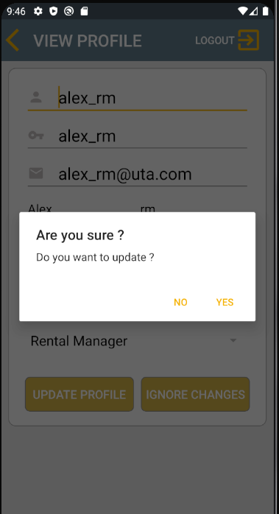

**Figure 5.2 Figure 5.3**

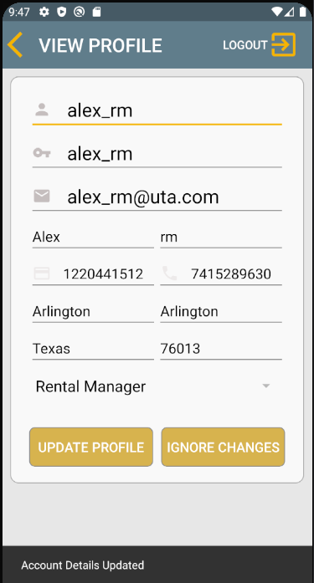 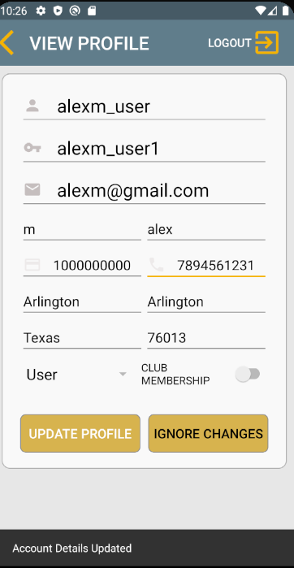

UC 6: Search Vehicles

|  |  |
| --- | --- |
| **Precondition: The system has an account for the System User in the Arlington Auto Car Rental System that is logged in and on User Home screen.** | |
| **Actor: User** | **System: Arlington Auto Car Rental System** |
|  | 0. System displays the User’s Home screen **(Figure 2.3).** |
| **1. TUCBW** the User selects the “Search Vehicles” function on User’s Home screen. | 2. The system displays the Search Vehicles screen **(Figure 6.1)**. |
| 3. The User fills the details and clicks the “Search” button. | *  4. The system retrieves the relevant list of available vehicles and displays them on Search Vehicles screen **(Figure 6.2)**. |
| **5. TUCEW** the User sees the relevant list of vehicles on Search Vehicles screen. |  |
| **Post condition: The system displays the relevant vehicles list.** | |

**Figure 2.3 Figure 6.1 Figure 6.2**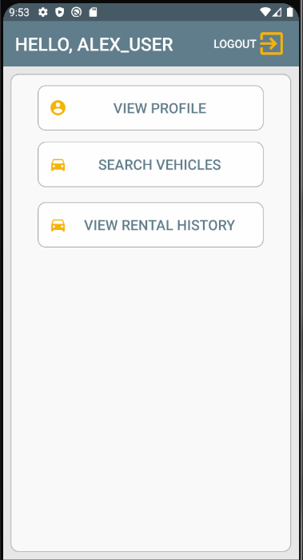 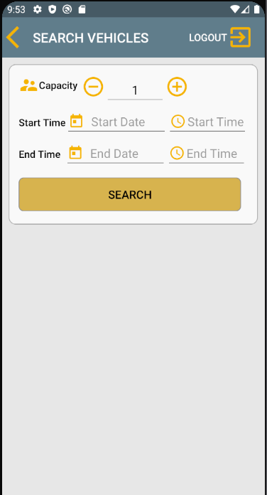 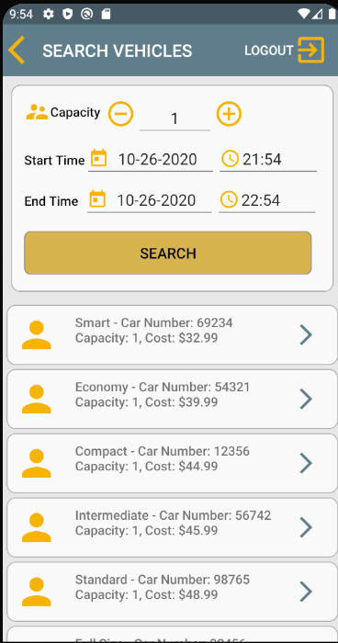

UC 7: Select Vehicle

|  |  |
| --- | --- |
| **Precondition: The system has an account for the System User in the Arlington Auto Car Rental System that is logged in and on Search Vehicles screen.** | |
| **Actor: User** | **System: Arlington Auto Car Rental System** |
|  | 0. System displays the user’s Search Vehicles Screen with the list of available vehicles **(Figure 6.2).** |
| **1. TUCBW** the User selects the ‘Select Vehicle’ function by choosing a vehicle from the User’s Search Vehicle Screen. | 2. The system displays the details of the selected vehicle **(Figure 7.1).** |
| **3. TUCEW** the User sees the selected vehicle from the list displayed on Selected Vehicle screen. |  |
| **Post condition: The system displays the details of the selected vehicle.** | |

**Figure 6.2 Figure 7.1**  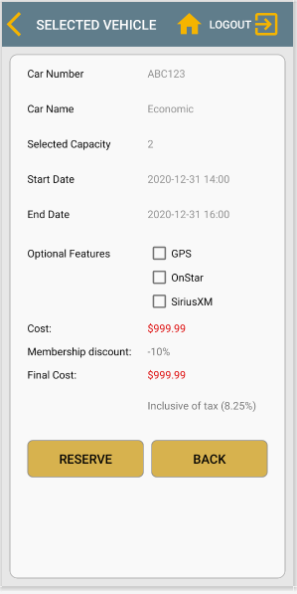

UC 8: Reserve Rental

|  |  |
| --- | --- |
| **Precondition: The system has an account for the System User in the Arlington Auto Car Rental System that is logged in and on User’s Selected Vehicles screen.** | |
| **Actor: User** | **System: Arlington Auto Car Rental System** |
|  | 0. System displays the User’s Selected Vehicle screen **(Figure 7.1)** |
| **1. TUCBW** the User may choose Optional Features and select the ‘Reserve’ function on the User’s Selected Vehicle screen by choosing the ‘Reserve’ option. | *  2. The system creates a reservation and displays the details of the reservation on Reservation Summary screen **(Figure 8.1)** |
| **3. TUCEW** the User sees the reserved rental on the Reservation Summary screen. |  |
| **Post condition: The system displays the details of the reserved rental.** | |

**Figure 7.1 Figure 8.1**  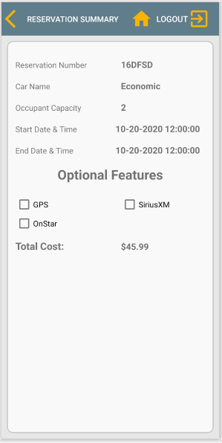

UC 9: View Rental History

|  |  |
| --- | --- |
| **Precondition: The system has an account for the System User in the Arlington Auto Car Rental System that is logged in and on User Home screen.** | |
| **Actor: User** | **System: Arlington Auto Car Rental System** |
|  | 0. System displays the User’s Home screen **(Figure 2.3)** |
| **1. TUCBW** the User selects the “View Rental History” function on User’s Home screen. | 2. The system displays the View Reservation History screen **(Figure 9.1)** |
| 3. The User enters the date & time and clicks the “Search” button. | *  4. The system retrieves the relevant list of user’s car rental(s) history and displays them on View Reservation History screen **(Figure 9.2)**.  If User has no reservation history, “No Reservations” toast message is returned **(Figure 9.3)**. |
| **5. TUCEW** the User sees the relevant list of car rental(s) on the View Reservation History screen. |  |
| **Post condition: The system displays the relevant car rental(s) list.** | |

**Figure 2.3 Figure 9.1**  **Figure 9.2**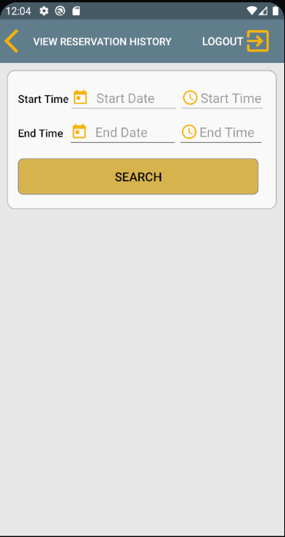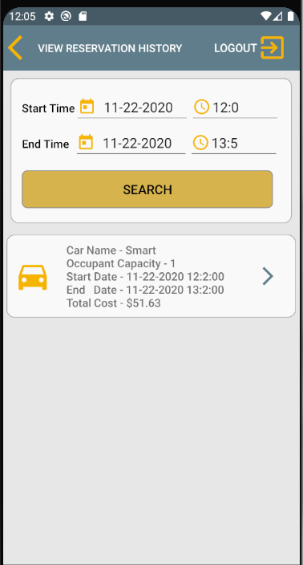

**Figure 9.3**

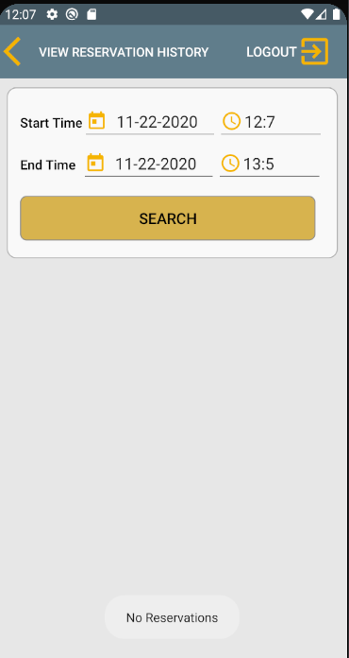

UC 10: View Reservation Summary

|  |  |
| --- | --- |
| **Precondition: The system has an account for the System User in the Arlington Auto Car Rental System that is logged in and on View Reservation History screen.** | |
| **Actor: User** | **System: Arlington Auto Car Rental System** |
|  | 0. System displays the View Reservation History screen with the list of user’s car rental(s) **(Figure 9.2).** |
| **1. TUCBW** the User selects the ‘View Reservation Summary’ function by choosing a rental from the View Reservation History screen. | 2. The system displays the details of the selected rental **(Figure 10.1).** |
| **3. TUCEW** the User sees the details of the selected reservation from the list displayed on Reservation Summary screen. |  |
| **Post condition: The system displays the details of the selected reservation.** | |

**Figure 9.2 Figure 10.1**  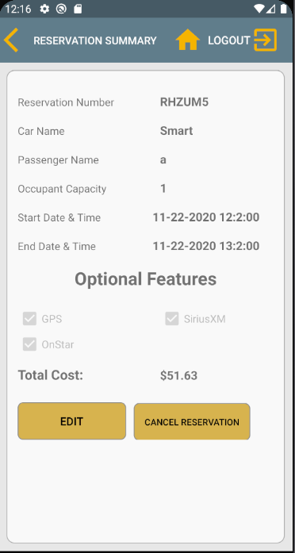

UC 11: Update Rental Details

|  |  |
| --- | --- |
| **Precondition: The system has an account for the System User in the Arlington Auto Car Rental System that is logged in and on Reservation Summary screen.** | |
| **Actor: User** | **System: Arlington Auto Car Rental System** |
|  | 0. System displays the Reservation Summary screen with the details of selected user’s reservation **(Figure 10.1).** |
| **1. TUCBW** the User selects the “Update Rental Details” function by choosing the “Edit” option on the Reservation Summary Screen. | 2. The system displays the Reservation Summary screen with modifiable fields **(Figure 11.1)** |
| 3.The System User updates one or more fields and clicks the “Save” button on Reservation Summary screen | 4. The system displays a confirmation message to the User on the Reservation Summary screen **(Figure 11.2).** |
| 5. The System user can either click ‘YES’ or ‘NO’ with respect to updating the reservation details. | *  6. The system updates the System User’s reservation details and displays the confirmation message on the Reservation Summary screen **(Figure 11.3)**. |
| **7. TUCEW** the System User sees ‘Reservation Updated’ message on the Reservation Summary screen. |  |
| **Post condition: The system displays the details of the selected reservation.** | |

**Figure 10.1 Figure 11.1 Figure 11.2**  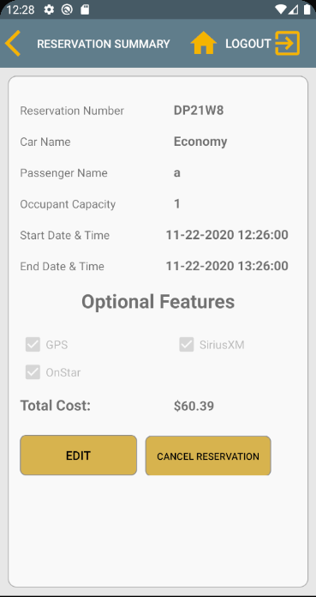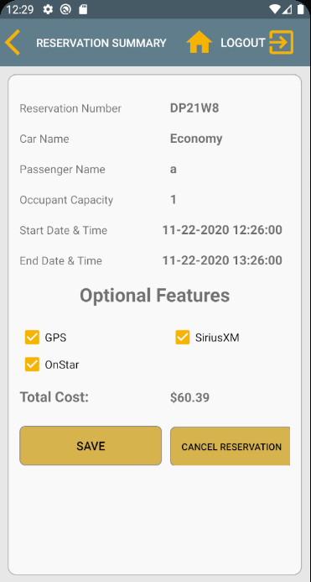 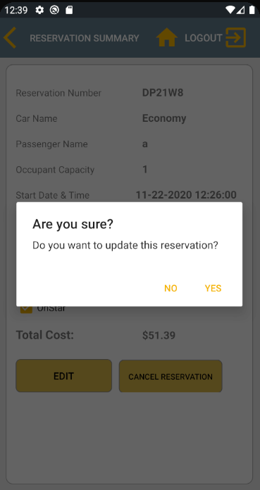

**Figure 11.3**

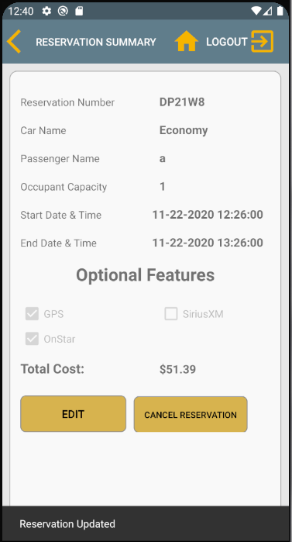

UC 12: Cancel Rental Reservation

|  |  |
| --- | --- |
| **Precondition: The system has an account for the System User in the Arlington Auto Car Rental System that is logged in and on Reservation Summary screen.** | |
| **Actor: User** | **System: Arlington Auto Car Rental System** |
|  | 0. System displays the Reservation Summary screen with the details of selected user’s reservation **(Figure 10.1).** |
| **1. TUCBW** the System User selects the “Cancel Rental Reservation” function on Reservation Summary screen. | 2. The system displays a confirmation message to the User on the Reservation Summary screen. **(Figure 12.1).** |
| 3. The System user can either click ‘YES’ or ‘NO’ with respect to cancelling the reservation. | *  4. The system updates the System User’s reservation status and redirects to the User Home screen **(Figure 12.2)**. |
| **5. TUCEW** the System User sees ‘Reservation Cancelled’ message and returns to the User’s Home screen. |  |
| **Post condition: The system cancels the selected reservation.** | |

**Figure 10.1 Figure 12.1 Figure 12.2** 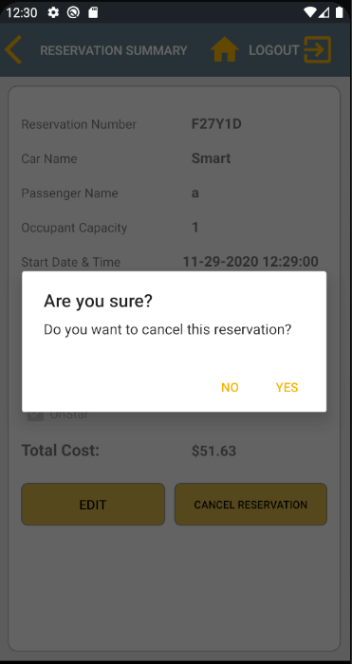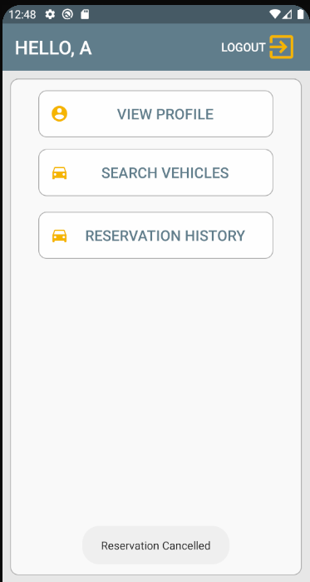

UC 13: Search All Users

|  |  |
| --- | --- |
| **Precondition: The system has an account for the Admin in the Arlington Auto Car Rental System that is logged in and on admin Home screen.** | |
| **Actor: Admin** | **System: Arlington Auto Car Rental System** |
|  | 0. System displays the Admin Home screen **(Figure 2.1)**. |
| **1. TUCBW** the admin selects the ‘Search All Users’ function from the Admin Home screen. | 2. The system displays the list of the users on the Search All Users screen. **(Figure 13.1)** |
| 3. The admin may enter the last name on Search All Users screen. | *  4. The system displays the list of users with the corresponding last name. **(Figure 13.2)** |
| **5. TUCEW** the admin sees the relevant list of users on Search All Users screen. |  |
| **Post condition: The system displays the details of the searched user(s) by last name.** | |

**Figure 2.1 Figure 13.1 Figure 13.2**

 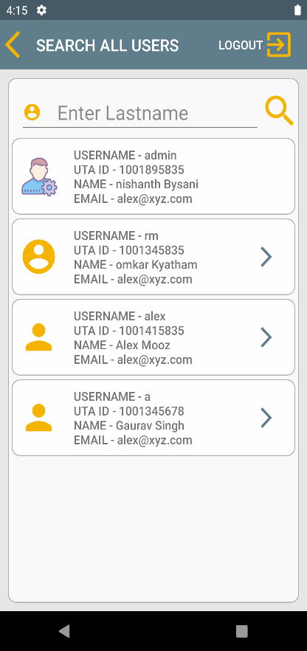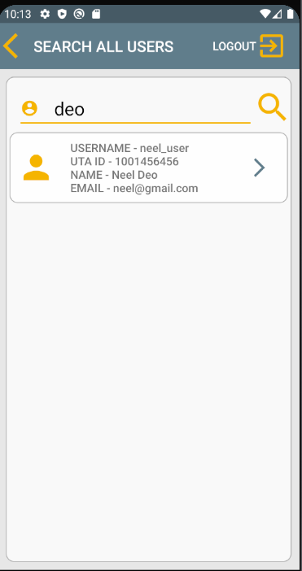

UC 14: View User

|  |  |
| --- | --- |
| **Precondition: The system has an account for the Admin in the Arlington Auto Car Rental System that is logged in and on Search All Users screen.** | |
| **Actor: Admin** | **System: Arlington Auto Car Rental System** |
|  | 0. System displays the Search All Users screen **(Figure 13.2)** |
| **1. TUCBW** the admin selects the ‘View User’ function by choosing a user from the Search All Users screen. | 2. The system displays the details of the selected user on User Profile screen. **(Figure 14.1)** |
| **3. TUCEW** the admin sees the selected user from the list displayed on User Profile screen. |  |
| **Post condition: The system displays the details of the selected user.** | |

**Figure 13.2 Figure 14.1**

 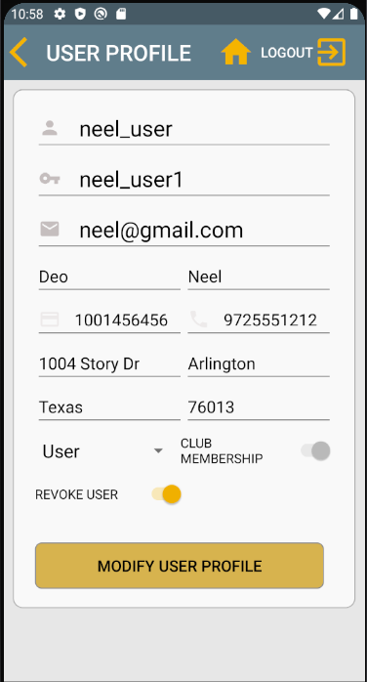

UC 15: Modify User Profile

|  |  |
| --- | --- |
| **Precondition: The system has an account for the Admin in the Arlington Auto Car Rental System that is logged in and on User Profile screen.** | |
| **Actor: Admin** | **System: Arlington Auto Car Rental System** |
|  | 0. System displays the User Profile screen **(Figure 14.1)** |
| **1. TUCBW** the Admin updates one or more fields and selects the ‘Modify User Profile’ function on the User Profile screen. | 2. The system displays a confirmation window to the system user on User Profile screen. **(Figure 15.1)** |
| 3. The Admin can either click ‘YES’ or ‘NO’ with respective to modify the user’s profile on User Profile screen. | *  4. The system modifies the user profile with altered fields and Account Details Updated message is displayed to the Admin on the User Profile screen. |
| **5. TUCEW** the Admin sees the selected user’s profile information displayed on User Profile screen. |  |
| **Post condition: The system displays the modified details of the selected user.** | |

**Figure 14.1 Figure 15.1 Figure 15.2**

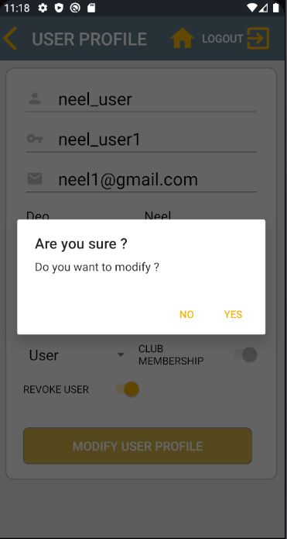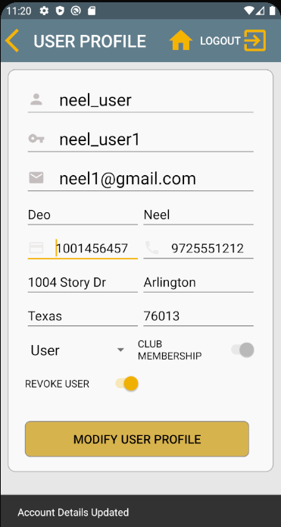

UC 16: View Reservation Calendar

|  |  |
| --- | --- |
| **Precondition: The system has an account for the Admin in the Arlington Auto Car Rental System that is logged in and on Rental Manager Home screen.** | |
| **Actor: Rental Manager** | **System: Arlington Auto Car Rental System** |
|  | 0. System displays the Rental Manager Home screen **(Figure 2.2)**. |
| **1. TUCBW** the admin selects the ‘View Reservation Calendar’ function from the Rental Manager Home screen. | 2. The system displays the Reservation Calendar screen **(Figure 16.1)** |
| 3. The User enters the Start Date & Time and End Date & Time, and clicks the “Search” button. | *  4. The system retrieves the relevant list of reservation(s) and displays them on Reservation Calendar screen **(Figure 16.2)**. |
| **5. TUCEW** the User sees the relevant list of reservation(s) on the Reservation Calendar screen. |  |
| **Post condition: The system displays the relevant list of reservation(s).** | |

**Figure 2.2 Figure 16.1 Figure 16.2**

 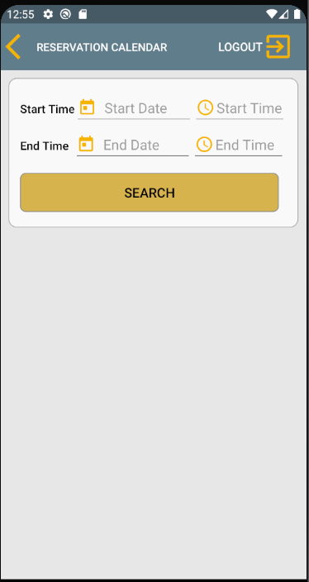 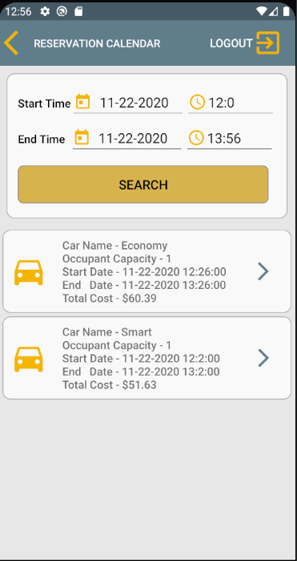

UC 17: View Rental Details

|  |  |
| --- | --- |
| **Precondition: The system has an account for the System User in the Arlington Auto Car Rental System that is logged in and on Reservation Calendar screen.** | |
| **Actor: Rental Manager** | **System: Arlington Auto Car Rental System** |
|  | 0. System displays the Reservation Calendar screen with the relevant list of reservation(s) **(Figure 16.2).** |
| **1. TUCBW** the User selects the ‘View Rental Details’ function by choosing a reservation from the Reservation Calendar screen. | 2. The system displays the details of the selected reservation **(Figure 17.1).** |
| **3. TUCEW** the User sees the details of the selected reservation from the list displayed on Reservation Summary screen. |  |
| **Post condition: The system displays the details of the selected reservation.** | |

**Figure 16.2 Figure 17.1**

 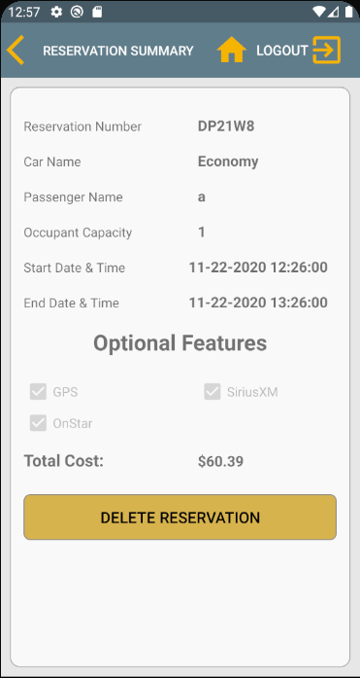

UC 18: Delete Reservation

|  |  |
| --- | --- |
| **Precondition: The system has an account for the System User in the Arlington Auto Car Rental System that is logged in and on Reservation Summary** **screen.** | |
| **Actor: Rental Manager** | **System: Arlington Auto Car Rental System** |
|  | 0. System displays the Reservation Summary screen with the details of selected reservation **(Figure 17.1).** |
| **1. TUCBW** the System User selects the “Delete Reservation” function on Reservation Summary screen. | 2. The system displays a confirmation message to the User on the Reservation Summary screen **(Figure 18.1).** |
| 3. The System user can either click ‘YES’ or ‘NO’ with respect to deleting the reservation. | *  4. The system updates the reservation status and displays the confirmation message on the Rental Manager Home screen **(Figure 2.2)**. |
| **5. TUCEW** the System User sees ‘Reservation Deleted’ message and returns to the Rental Manger Home screen. |  |
| **Post condition: The system deletes the selected reservation.** | |

**Figure 17.1 Figure 18.1 Figure 2.2**

 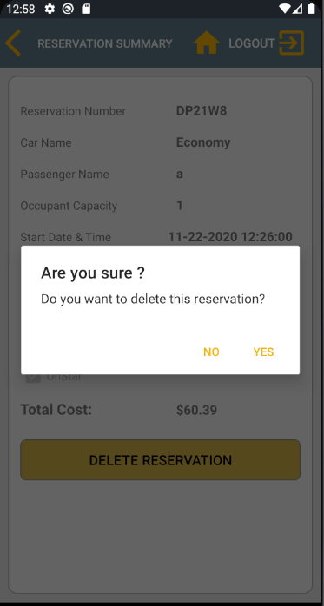 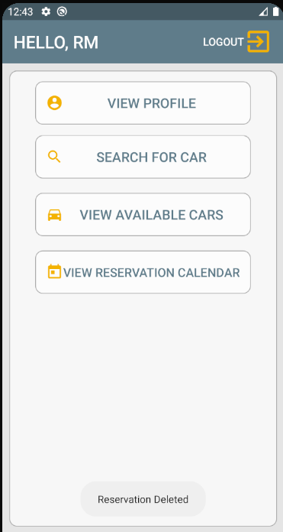

UC 19: View Available Cars

|  |  |
| --- | --- |
| **Precondition: The system has an account for the System User in the Arlington Auto Car Rental System that is logged in and on Rental Manager Home screen.** | |
| **Actor: Rental Manager** | **System: Arlington Auto Car Rental System** |
|  | 0. System displays the Rental Manager Home screen **(Figure 2.2)**. |
| **1. TUCBW** the rental manager selects the ‘View Available Cars’ function on the Rental Manager Home screen. | 2. The system displays the View Available Cars screen **(Figure 19.1)**. |
| 3. The rental manager fills the details and clicks ‘Search’ button on View Available Cars screen. | 4. The system displays the list of the available cars on View Available Cars screen **(Figure 19.2)** |
| **5. TUCEW** the rental manager sees the relevant list of available cars on View Available Cars screen. |  |
| **Post condition: The system displays the details of the relevant car(s).** | |

**Figure 2.2 Figure 19.1 Figure 19.2**

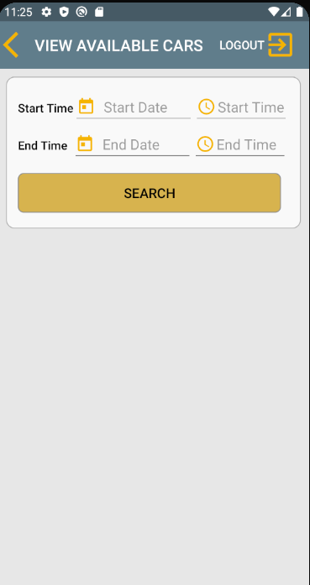 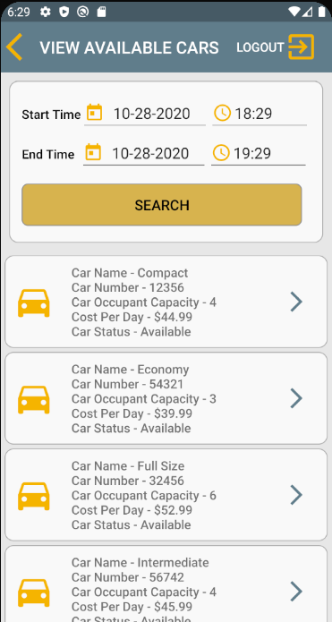

UC 20: Search for Car

|  |  |
| --- | --- |
| **Precondition: The system has an account for the System User in the Arlington Auto Car Rental System that is logged in and on Rental Manager Home screen.** | |
| **Actor: Rental Manager** | **System: Arlington Auto Car Rental System** |
|  | 0. System displays the Rental Manager Home screen **(Figure 2.2)**. |
| **1. TUCBW** the rental manager selects the ‘Search for Car’ function from the Rental Manager Home screen. | 2. The system displays the Search for Cars screen **(Figure 20.1)**. |
| 3. The rental manager enters the car name on the Search for Car screen. | *  4. The system displays the list of the available cars relative to the car name on Search for Cars screen **(Figure 20.2)**. |
| **5. TUCEW** the rental manager sees the relevant list of available cars on Search for Cars Screen. |  |
| **Post condition: The system displays the details of the relevant car(s).** | |

**Figure 2.2 Figure 20.1 Figure 20.2**

 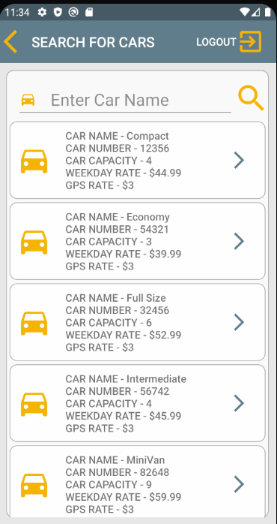 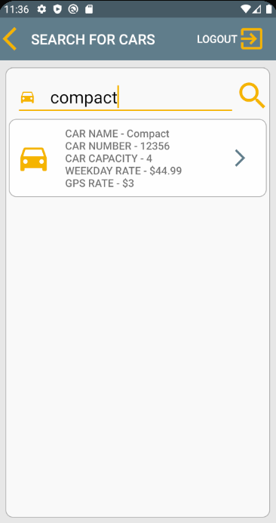

UC 21: View Selected Car

|  |  |
| --- | --- |
| **Precondition: The system has an account for the Rental Manager in the Arlington Auto Car Rental System that is logged in and on View Available Cars screen or Search for Cars screen.** | |
| **Actor: Rental Manager** | **System: Arlington Auto Car Rental System** |
|  | 0. System displays the Rental Manager View Available Cars Screen (**Figure 19.2)** (or) View Search for Car Screen **(Figure 20.2)** |
| **1. TUCBW** the Rental Manager selects the View Selected Car function by choosing a vehicle from the View Available Cars Screen (or) View Search for Car Screen. | 2. The system displays the details of the selected car on Car Details screen **(Figure 21.1)** |
| **3. TUCEW** the rental manager sees the details of the selected car on Car Details Screen. |  |
| **Post condition: The system displays the details of the selected car.** | |

**Figure 19.2 Figure 20.2 Figure 21.1**

  